Week8 – Satish Ramachandran

# Problem#1

'''

Week 8 - Problem #1

Fibonacci - auto-encoder

'''

import numpy as np

import matplotlib.pyplot as plt

import tensorflow as tf

from tensorflow.keras.models import Sequential

from tensorflow.keras.layers import Dense

from sklearn import metrics

from numpy.random import seed

from tensorflow import set_random_seed

def create_dataset():

# 20 data points

x = np.array([np.arange(0,20)])

# Data is the fibonacci series

fib = [1,1]

num = 20

for ctr in np.arange(2, num):

fib.append(fib[ctr-1] + fib[ctr - 2])

plt.title('generated data')

plt.scatter(range(20), fib)

plt.show()

plt.waitforbuttonpress()

plt.close()

np_array_data = np.array([fib])

np_array_data.astype(np.float32)

return (x, np_array_data)

x, y = create_dataset()

print(x)

print(y)

seed(1)

set_random_seed(2)

model = Sequential()

# Hidden layer with 20 inputs

model.add(Dense(6, input_dim=x.shape[1], activation='relu'))

# Output layer is the same as input

model.add(Dense(x.shape[1]))

model.compile(loss='mean_squared_error', optimizer='adam')

model.summary()

#Train the model. The output is the same as the input

model.fit(y, y, verbose = 0, epochs=500)

predict = model.predict(y)

print(predict)

#Calculate the RMSE

score = np.sqrt(metrics.mean_squared_error(predict, y))

print("RMSE score: {}".format(score))

plt.title('model output - 6 hidden nodes - 500 epochs')

plt.scatter(x, y, c='red', s=150)

plt.scatter(x, predict, c = 'blue')

plt.show()

plt.waitforbuttonpress()

**Observations:**

Tried the problem with different number of epochs and different number of hidden layers. When the number of epochs is less, the number of hidden layers makes a lot of difference. For example, when the number of epochs is 200, the number of nodes in the hidden layer makes a lot of difference.

Including plots of the different numbers of input nodes with 200 epochs, and also one plot with 6 input nodes and 500 epochs

**The RED dots are the target Fibonacci series, and BLUE dots is the what the model predicts.**

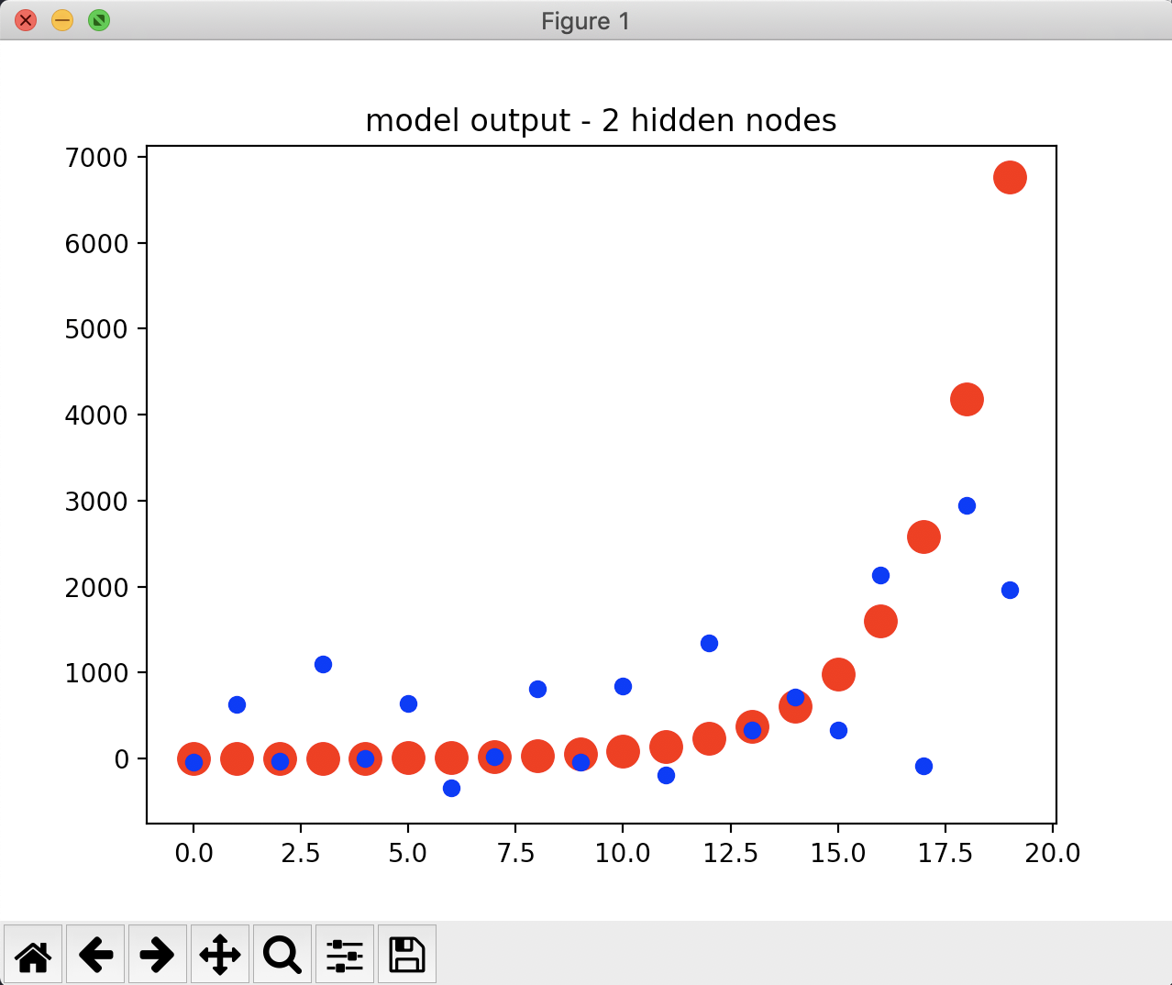

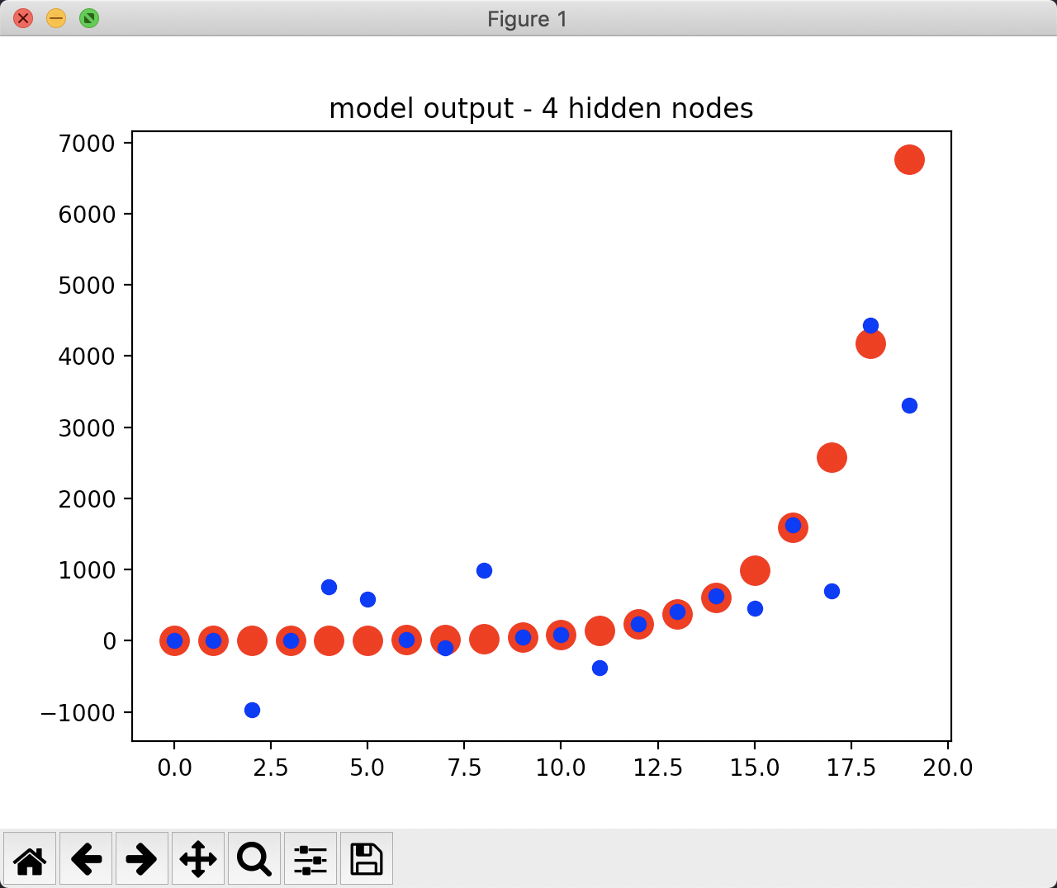

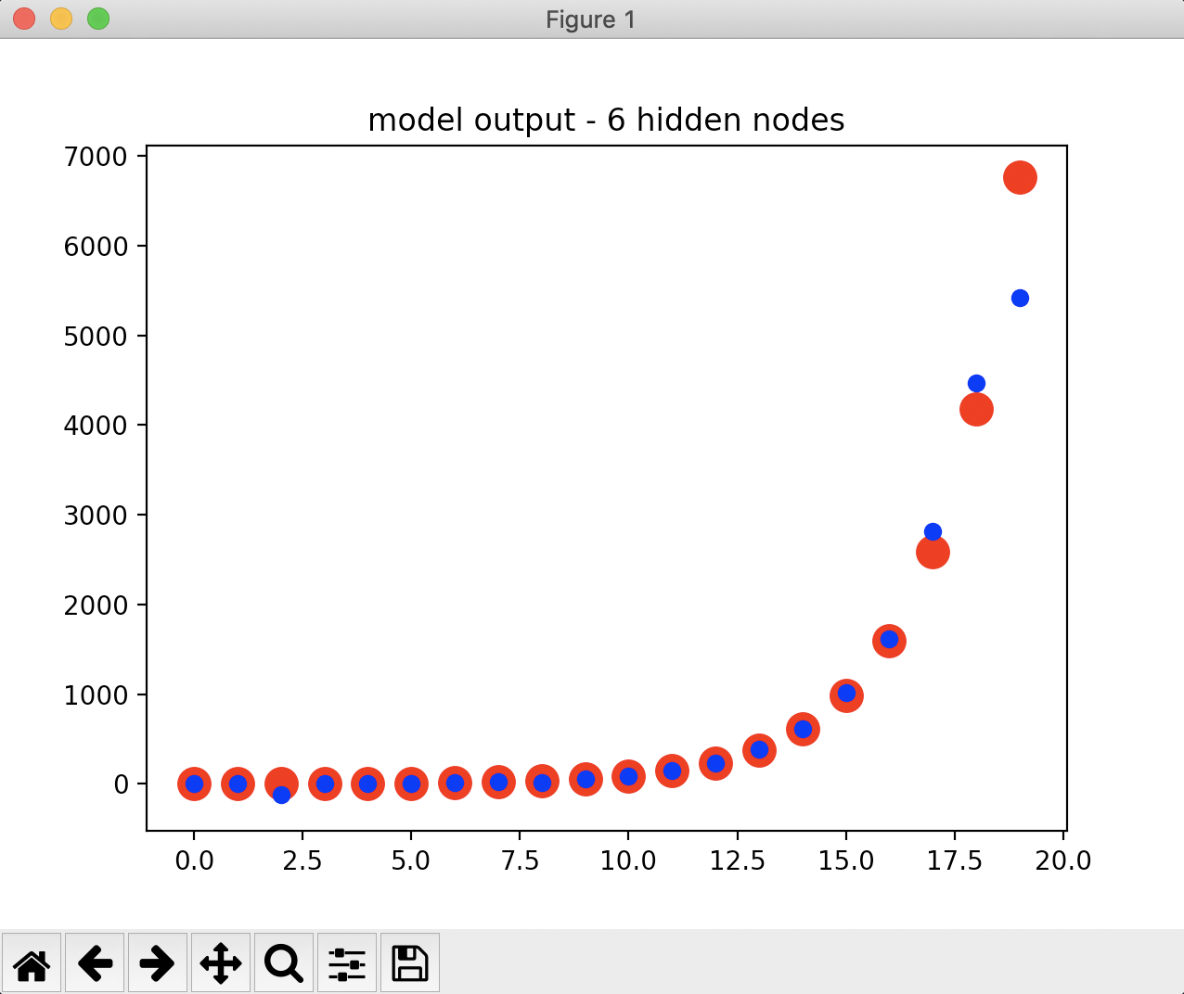

Now, increase the number of epochs to 500, and the fit is much better.

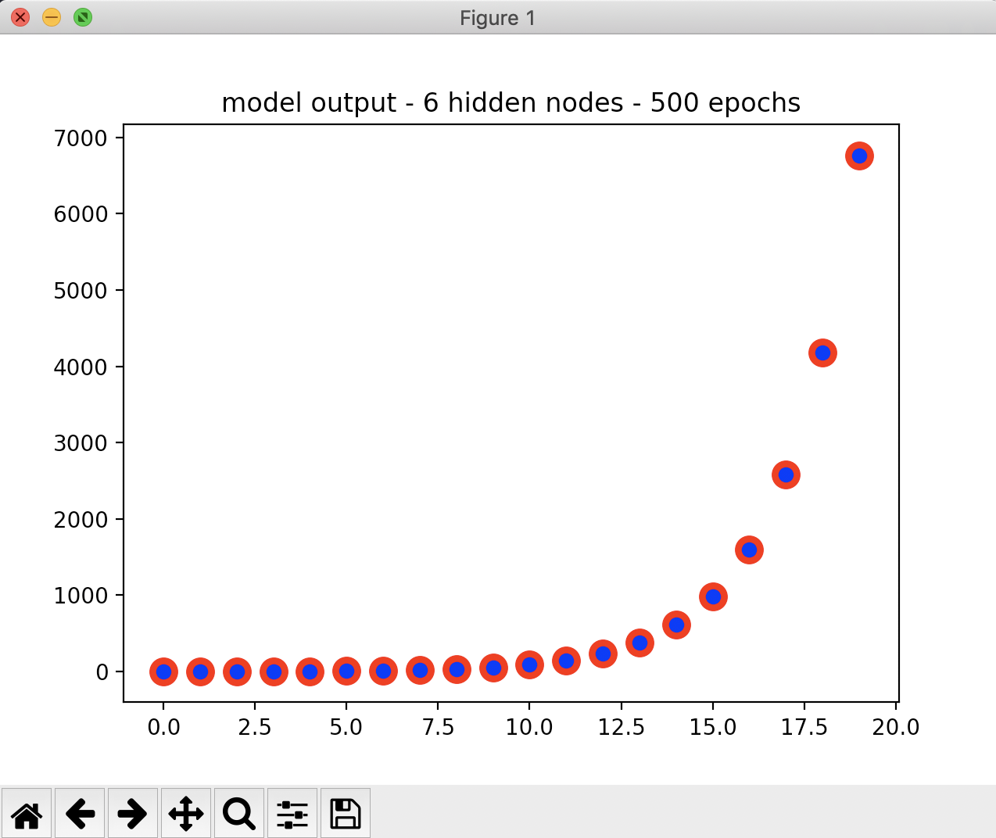

The RMSE reflects exactly how the plots map

For 2 nodes:

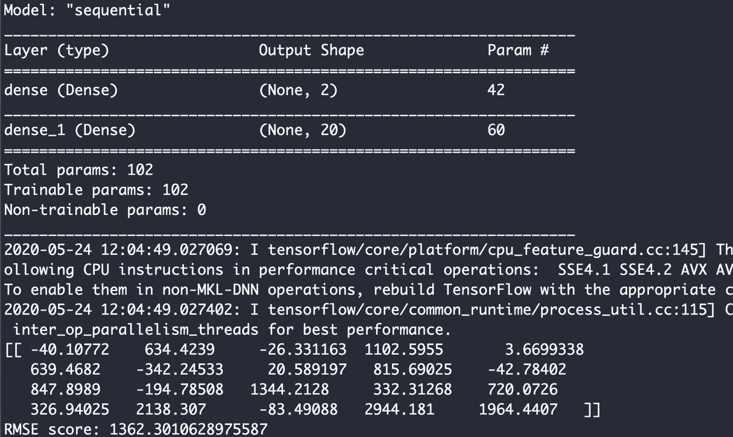

For 6 nodes:

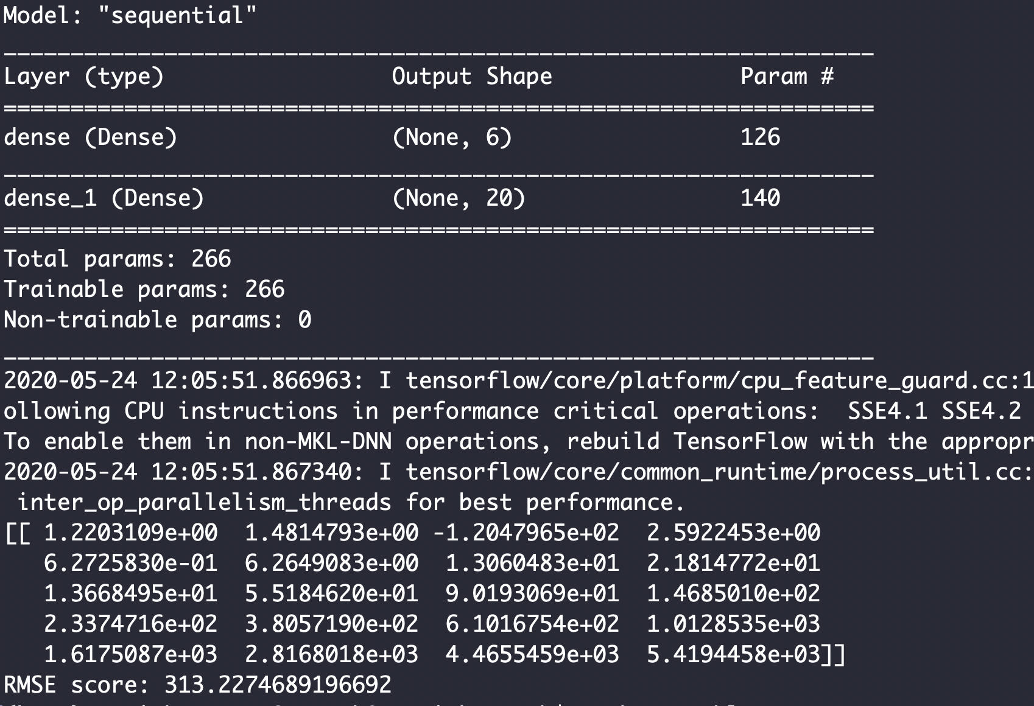

As can be seen, the score gets better.

But, there is a significant improvement when the number of epochs is imcreased. Now, with 500 epochs.

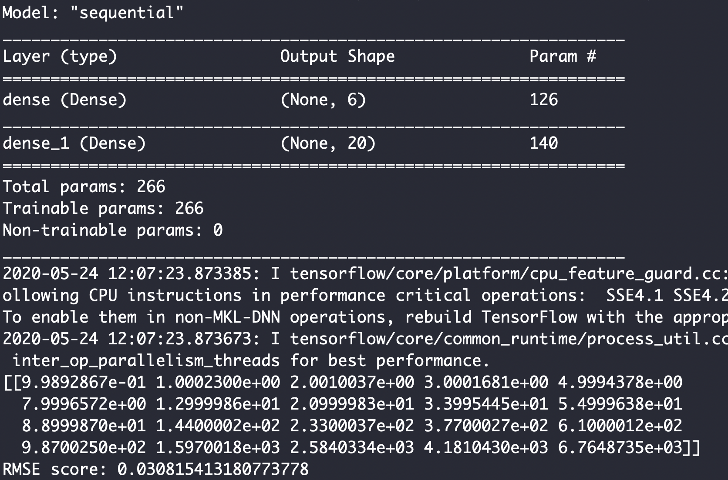

# Problem #2

'''

Week 8 - Problem #2

Cat image - auto-encoder

'''

import numpy as np

import matplotlib.pyplot as plt

import tensorflow as tf

from tensorflow.keras.models import Sequential

from tensorflow.keras.layers import Dense

from sklearn import metrics

from PIL import Image

from numpy.random import seed

from tensorflow import set_random_seed

def show_image(img, title):

fig, aux = plt.subplots(figsize=(5,5))

aux.imshow(img, cmap='gray')

plt.title(title)

plt.show()

plt.waitforbuttonpress()

def read_image():

img = Image.open('cat.jpg')

show_image(img, 'actual image')

# Resize the image

img.load()

img = img.resize((128, 128), Image.ANTIALIAS)

img_array = np.asarray(img)

img_array = img_array.flatten()

img_array = np.array([img_array])

img_array = img_array.astype(np.float32)

print(img_array)

return (img_array)

#return img

def define_model(hidden_layers, image_data):

# define the keras model

seed(1)

set_random_seed(2)

model = Sequential()

# Add a hidden layer

model.add(Dense(hidden_layers, input_dim=image_data.shape[1], activation='relu'))

model.add(Dense(image_data.shape[1]))

model.compile(loss='mean_squared_error', optimizer='adam')

model.summary()

return model

def train_and_predict_model(model, image_data):

seed(1)

set_random_seed(2)

model.fit(image_data, image_data, verbose = 0, epochs=20)

predict = model.predict(image_data)

restored_img_data = predict[0].reshape(128, 128, 3)

restored_img_data = restored_img_data.astype(np.uint8)

restored_img = Image.fromarray(restored_img_data, 'RGB')

return restored_img

# Get the image data

image_data = read_image()

# model with 4 input layers

model1 = define_model(4, image_data);

restored_img = train_and_predict_model(model1, image_data)

show_image(restored_img, 'restored image - 4 layers')

# model with 8 input layers

model2 = define_model(8, image_data);

restored_img = train_and_predict_model(model2, image_data)

show_image(restored_img, 'restored image - 8 layers')

# model with 12 input layers

model3 = define_model(12, image_data);

restored_img = train_and_predict_model(model3, image_data)

show_image(restored_img, 'restored image - 12 layers')

# model with 20 input layers

model4 = define_model(20, image_data);

restored_img = train_and_predict_model(model4, image_data)

show_image(restored_img, 'restored image - 20 layers')

These are the image plots with different number of layers with 20 epochs.

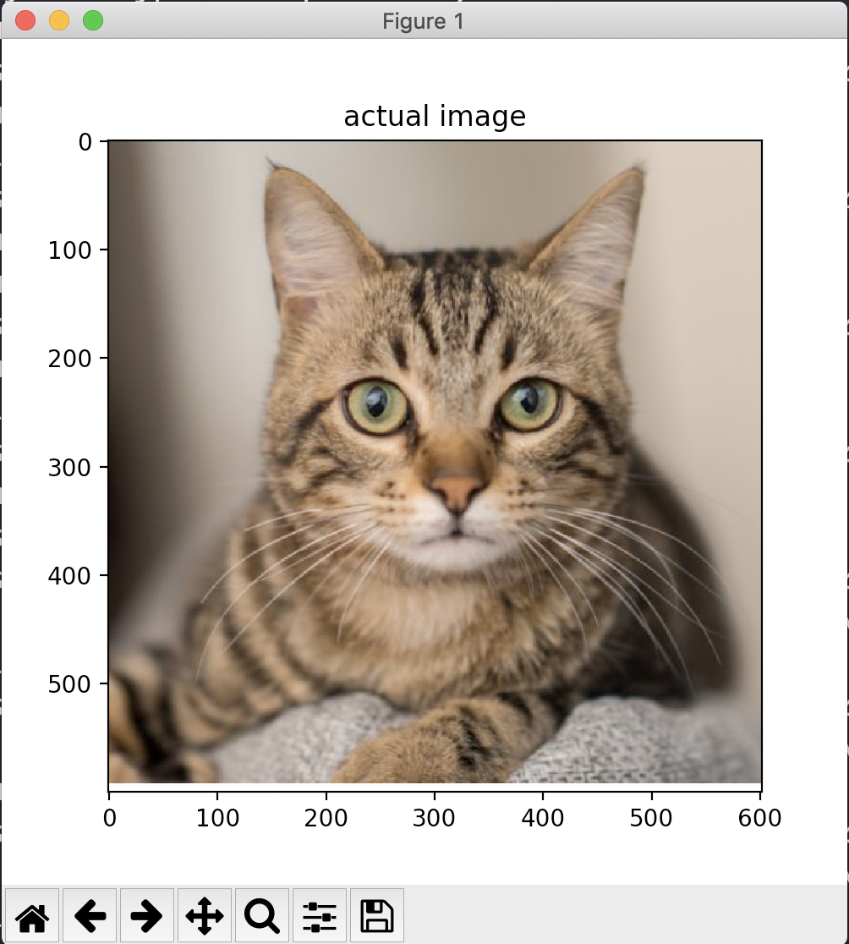

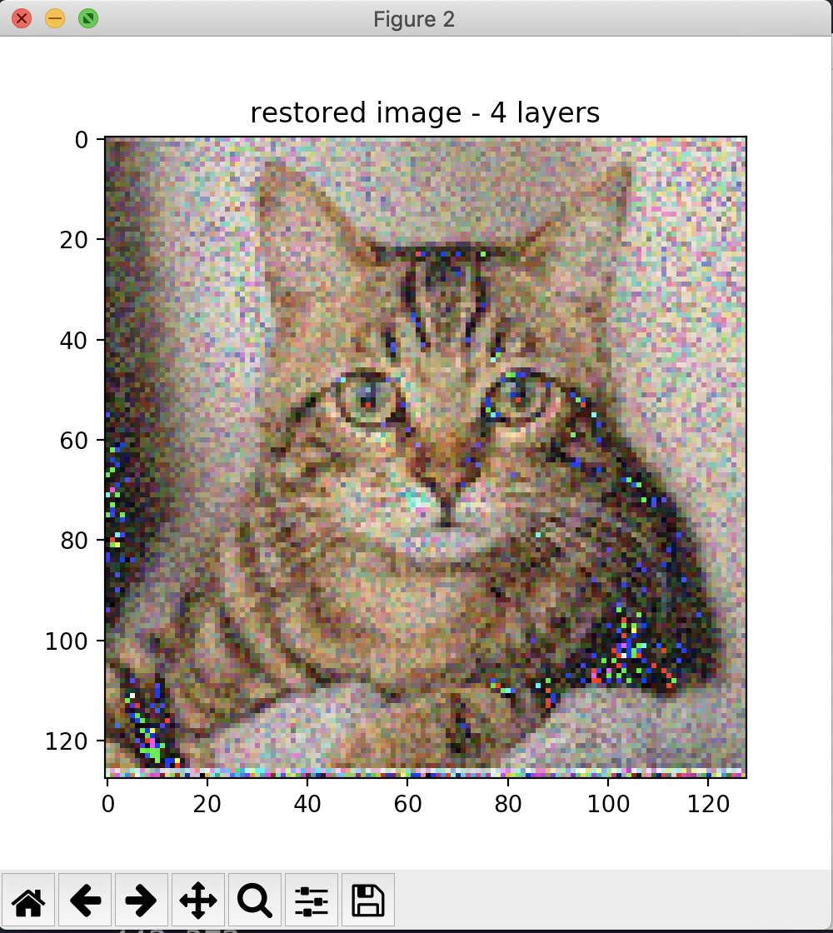

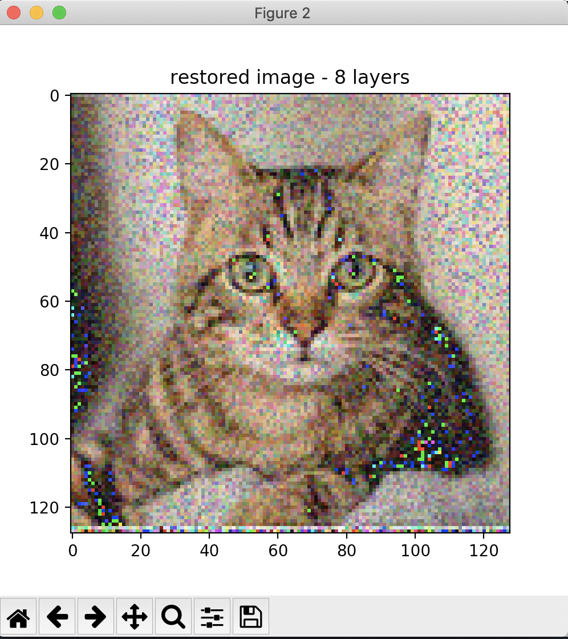

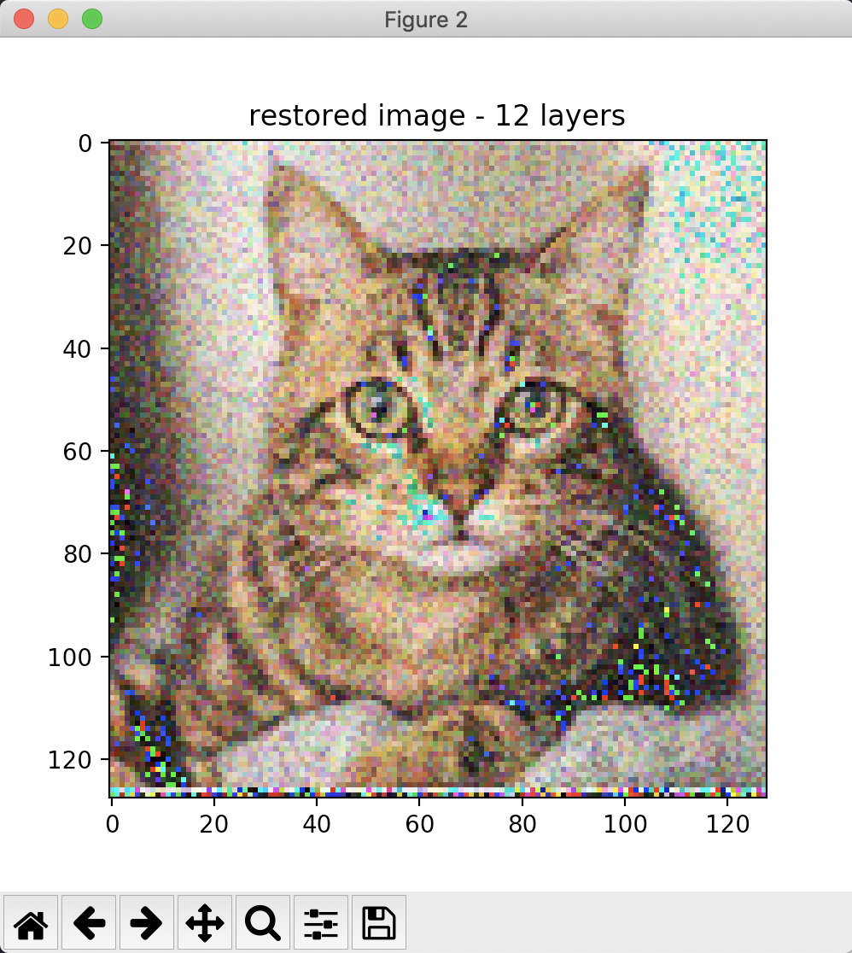

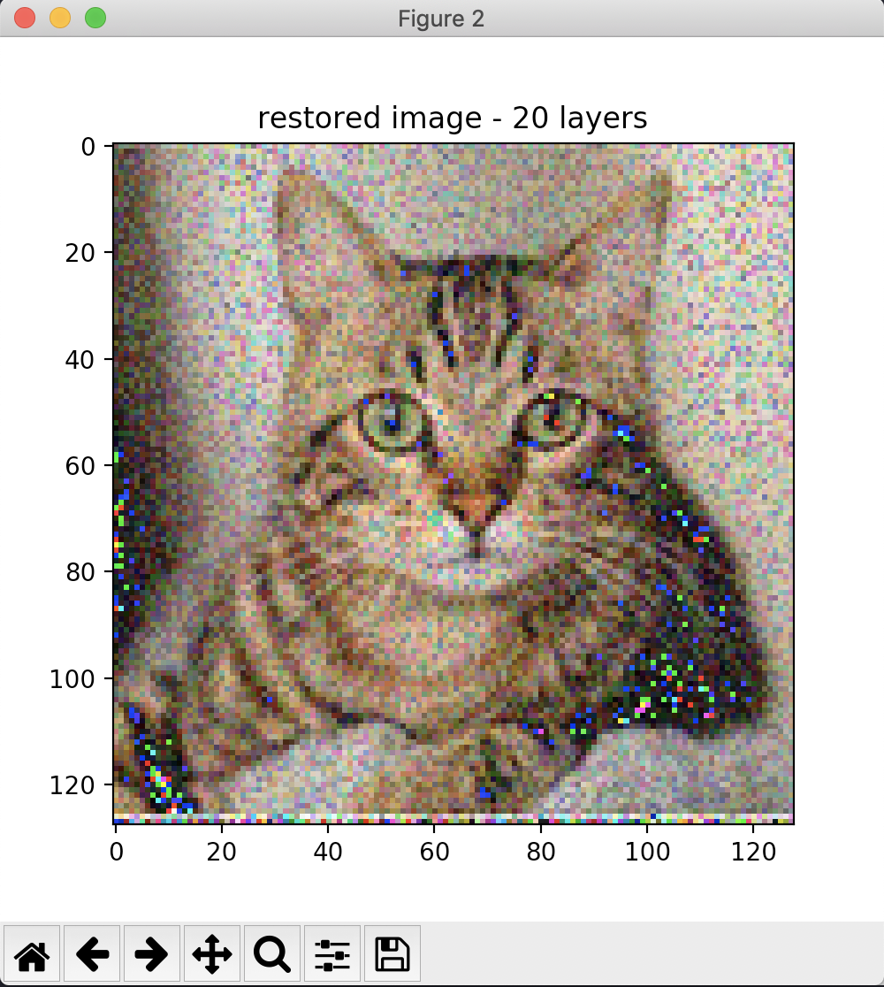

Now, there is a significant improvement when the number of epochs is increased to a few hundreds. An example here with 200 epochs and 8 layers.

As can be seen, there is a big difference with the same number of hidden layers with much fewer epochs.

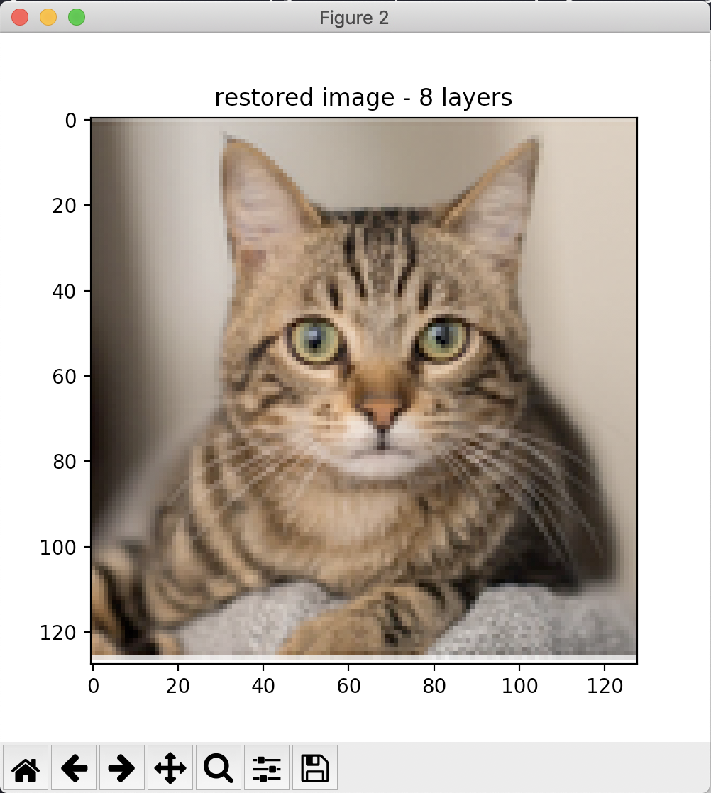

# Problem #3

'''

Week8 - Problem 3

Entropy, Cross entropy and KL divergence

'''

import numpy as np

def entropy(data):

return np.sum(-data * np.log(data))

def x_entropy(data1, data2):

return np.sum(-data1 * np.log(data2))

def kl_divergence(data1, data2):

return np.sum(-data1 * np.log(data2/data1))

img1_dist = np.array([35, 36, 45, 95, 24, 15, 6]) / 256

img2_dist = np.array([20, 56, 85, 52, 22, 20, 1]) / 256

print('Entropy of img1 distribution: {}'.format(entropy(img1_dist)))

print('Entropy of img2 distribution: {}'.format(entropy(img2_dist)))

print('Cross Entropy of img1 w.r.t img2 distribution: {}'.format(x_entropy(img1_dist, img2_dist)))

print('Cross Entropy of img2 w.r.t img1 distribution: {}'.format(x_entropy(img2_dist, img1_dist)))

print('KL divergence of img1 w.r.t img2 distribution: {}'.format(kl_divergence(img1_dist, img2_dist)))

print('KL divergence of img2 w.r.t img1 distribution: {}'.format(kl_divergence(img2_dist, img1_dist)))

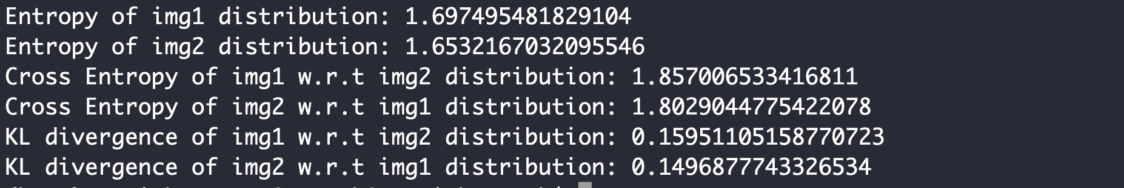

The output from the code matches the expected output in the problem statement.